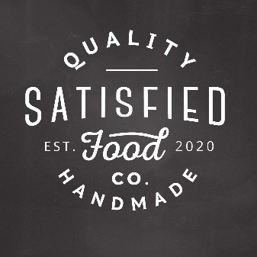

**Product Order Form**

**Smoked Pimento Cheese: Cup $8 Pint $16 Quart $ 30**

**XXX Hot Smoked Pimento Cheese Cup $9 Pint $18 Quart $35**

**Smoked Salmon Spread Cup $7 Pint $14 Quart $25**

**Mexican Chorizo Dip Cup $6 Pint $12 Quart $22**

**Buffalo Chicken Dip Cup $5 Pint $10 Quart $18**

Please send all orders to [satisfiedfoodco@gmail.com](mailto:satisfiedfoodco@gmail.com).

Please allow us 72 hours to fill orders. Also include any special instructions or dietary requests as needed.

Payment can be sent to:

PayPal: satisfiedfoodco@gmail.com

Venmo: @satisfiedfoodco

Pay upon pick up or delivery-